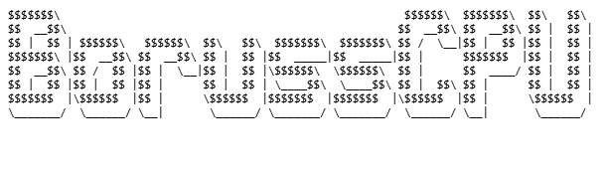®

Boruss® CPU Architecture
Software Developer’s Manual

Volume:
1

NOTE: This document contains Boruss® CPU Architecture Software Developer's Manual.

October 2025

Notices & Disclaimers
Boruss CPU technology require use hardware
CHAPTER 1
ABOUT THIS MANUAL

The Boruss CPU Architecture Software Developer’s Manual, Volume 1 describes the architecture and programming environment of Boruss® CPU architecture processor.

  - BORUSS® CPU PROCESSORS COVERED IN THIS MANUAL
- BorussCPU “Laibach”
  - OVERVIEW OF VOLUME 1: BASIC ARCHITECTURE
A description of this manual’s content follows:
Chapter 1 – About This Manual. Gives an overview of the BorussCPU.
Chapter 2 - Boruss® Architecture. Introduces the Boruss CPU architecture and gives overview of the features.
Chapter 3 – Basic Execution Environment. Introduces the model of memory organization and describes the register set used by applications.
Chapter 4 – Instruction Set Summary. List all BorussCPU instructions
  - NOTATIONAL CONVENTION
This manual uses typical notation described below.
    - Bit and Byte Order

- Bit order (in byte) specifies how bits are arranged within a single byte
- MSB (Most Significant Bit) leftmost bit is the most significant (bit 7)
- LSB (Least Significant Bit first) leftmost bit is the least significant (bit 0)

MSB0: b7 b6 b5 b4 b3 b2 b1 b0 (bits numbered 7 down to 0, left to right)
LSB0: b0 b1 b2 b3 b4 b5 b6 b7 (bits numbered 0 up to 7, left to right)
|------------8 bits-----------|

- Byte Order (Endianness)
- Big-endian: Most significant byte first (higher address = less significant)
- Little-endian: Least significant byte first (lower address = less significant)
Memory addresses: 0 1 2 3
Big-endian: [0x12] [0x34] [0x56] [0x78]
Little-endian: [0x78] [0x56] [0x34] [0x12]

CHAPTER 2
BorussCPU® Architecture

  - BORUSS® CPU ARCHITECTURE
This chapter describes all BorussCPU components
    - Arithmetic-Logic Unit
Performs arithmetic (adding, subtracting) and logical(AND, OR, XOR) operations based on operation code received from CPU.
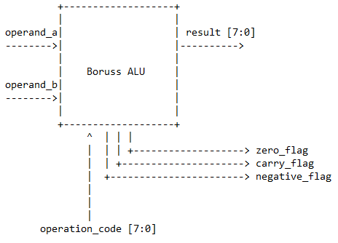
Figure 1 BorussCPU ALU inputs and outputs overview
2.1.1.1 ALU inputs and outputs
Name | Role | Description | Width
operand_a | Input | operand A | 8 bits
operand_b | Input | operand B | 8 bits
operation_code | Input | operation code | 8 bits
Table 1 ALU inputs overview

Name | Role | Description | Width
result | Output | Operation result | 8 bits
zero_flag | Output | Set when result is zero | 1 bit
carry_flag | Output | Set when carry occurred | 1 bit
negative_flag | Output | Set when result is negative (bit 7 is set to 1) | 1 bit
Tabela 2 ALU outputs overview
2.1.1.2 ALU operation processing

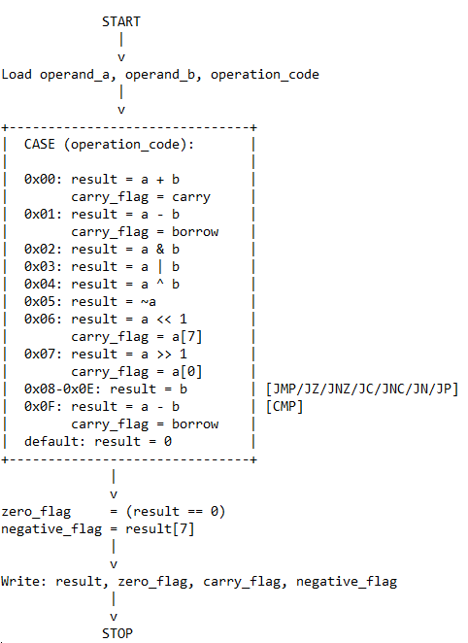
Figure 2 ALU operation processing flow chart
ALU gets the information about what operation is needed to be performed on the 8-bits wide input bus named “operation_code”. Based on that ALU selects and performs the operation and puts the outcome to the “result” 8-bits wide bus.
Operation name | Code | Used flags
ADD | 0x0 (8'b00000000) | carry_flag
When operation code value is 0x0 that means the ADD operation is requested. Operands A and B are added and result can be longer (9 bits) that two input operands because the result can overflow. In that case the oldest bit (MSB) is stored in carry_flag and the rest written to the result.
Example:
operand_a = 8’11111111 (0xFF, 8`d255, 255)
operand_b = 8’00000001 (0x1, 8’d1, 1)

8’b11111111 + 8’b00000001 = 9’b100000000 (0x100, 9’d256, 255 + 1 = 256)

result = 8’b00000000
carry_flag = 1’b1
zero_flag = 1’b0 (when result is zero)
negative_flag = 1’b0 (when result[7] set to 1)

Operation name | Code | Used flags
SUB | 0x1 (8'b00000001) | carry_flag
When operation code value is 0x1 that means the SUB operation is requested. Operands A and B are subtracted and result can be longer (9 bits) that two input operands because the result can borrow. In that case the oldest bit (MSB) is stored in carry_flag and the rest written to the result.
Example:
operand_a = 8’00000101 (0x5, 8`d5, 5)
operand_b = 8’00001000 (0x8, 8’d8, 8)

8’00000101 - 8’00001000 = 9’b111111101 (0xFFFD, -8’d3, 5 – 8 = -3)

result = 8’b11111101
carry_flag = 1’b1
zero_flag = 1’b1
negative_flag = 1’b1

Note: When operand_a < operand_b then carry_flag is set to 1.

Operation name | Code | Used flags
AND | 0x2 (8'b00000010) | -
When operation code value is 0x2 that means the logical AND operation is requested.
Example:
operand_a = 8’00000101 (0x5, 8`d5, 5)
operand_b = 8’00001000 (0x8, 8’d8, 8)

8’00000101 & 8’00001000 = 8’b00000000 (0x0, 8’d0)

result = 8’b00000000
zero_flag = 1’b1
negative_flag = 1’b0

Operation name | Code | Used flags
OR | 0x3 (8'b00000011) | -
When operation code value is 0x3 that means the logical OR operation is requested.
Example:
operand_a = 8’00000101 (0x5, 8`d5, 5)
operand_b = 8’00001000 (0x8, 8’d8, 8)

8’00000101 | 8’00001000 = 8’b00001101 (0xD, 8’d13)

result = 8’b00001101
zero_flag = 1’b0
negative_flag = 1’b0

Operation name | Code | Used flags
XOR | 0x4 (8'b00000100) | -
When operation code value is 0x4 that means the logical XOR operation is requested.
Example:
operand_a = 8’00000101 (0x5, 8`d5, 5)
operand_b = 8’00001001 (0x9, 8’d9, 9)

8’00000101 ^ 8’00001000 = 8’b00001100 (0xD, 8’d12)

result = 8’b00001100
zero_flag = 1’b0
negative_flag = 1’b0

Operation name | Code | Used flags
NOT | 0x5 (8'b00000101) | -
When operation code value is 0x5 that means the logical NOT operation is requested.
Example:
operand_a = 8’00000101 (0x5, 8`d5, 5)

~8’00000101 = 8’b11111010 (0xD, 8’d12)

result = 8’b11111010
zero_flag = 1’b0
negative_flag = 1’b0

Operation name | Code | Used flags
SHL | 0x6 (8'b00000110) | carry_flag
When operation code value is 0x6 that means shift SHL left operation is requested.
Example:
operand_a = 8’00000101 (0x5, 8`d5, 5)

8’00000101<<1 = 8’b00001010 (0xA, 8’d10)

result = 8’b00001010
carry_flag = 1’b0
zero_flag = 1’b0
negative_flag = 1’b0

Operation name | Code | Used flags
SHR | 0x7 (8'b00000111) | carry_flag
When operation code value is 0x6 that means shift right SHL operation is requested.
Example:
operand_a = 8’00000101 (0x5, 8`d5, 5)

8’00000101>>1 = 8’b0000010 (0xA, 8’d2)

result = 8’b00000010
carry_flag = 1’b1
zero_flag = 1’b0
negative_flag = 1’b0

Operations names | Codes | Used flags
JMP, JZ, JNZ, JC, JNC, JN, JP | 0x8 -0xE (8'b00001000 – 8b’00001110) | carry_flag, zero_flag, negative_flag
When operation code value is 0x8-0xE that means jump xxx operation is requested.
Example:
operand_a - ignored
operand_b = 8’01010010 (0x50, 8`d82, 82)

Address | Instruction | Comment
-----------|----------------|----------
0x10 | JMP 0x50 | jump to address 0x50
0x11 | (omitted) | this code is omitted
...
0x50 | ADD R1, R2 | Continue from here…

result = 01010010
carry_flag = 1’b0
zero_flag = 1’b0
negative_flag = 1’b0

Note: Jumps are not handled by ALU but always returns operand_b which is the jump address.

Operation name | Code | Used flags
CMP | 0xF (8b’00001111) | carry_flag, zero_flag, negative_flag
When operation code value is 0xF that means CMP operation is requested.
Example:
operand_a = 8’00000101 (0x5, 8`d5, 5)
operand_b = 8’00001001 (0x9, 8’d9, 9)

operand_a - operand_b = 8’00000101 - 8’00001001 = 8b11111100

carry_flag = 1’b1
zero_flag = 1’b0
negative_flag = 1’b1

Result: operand_a < operand_b

Flag status | Result | Condition
zero_flag = 1 | operand_a == operand_b | Equal
zero_flag = 0 | operand_a != operand_b | Not equal
carry_flag = 1 | operand_a < operand_b | A less than B
carry_flag = 0 | operand_a >= operand_b | A greater than B
negative_flag = 1 | Negative value | -

Note: CMP result is not written to result register. CMP operation result can be read by flags status.

